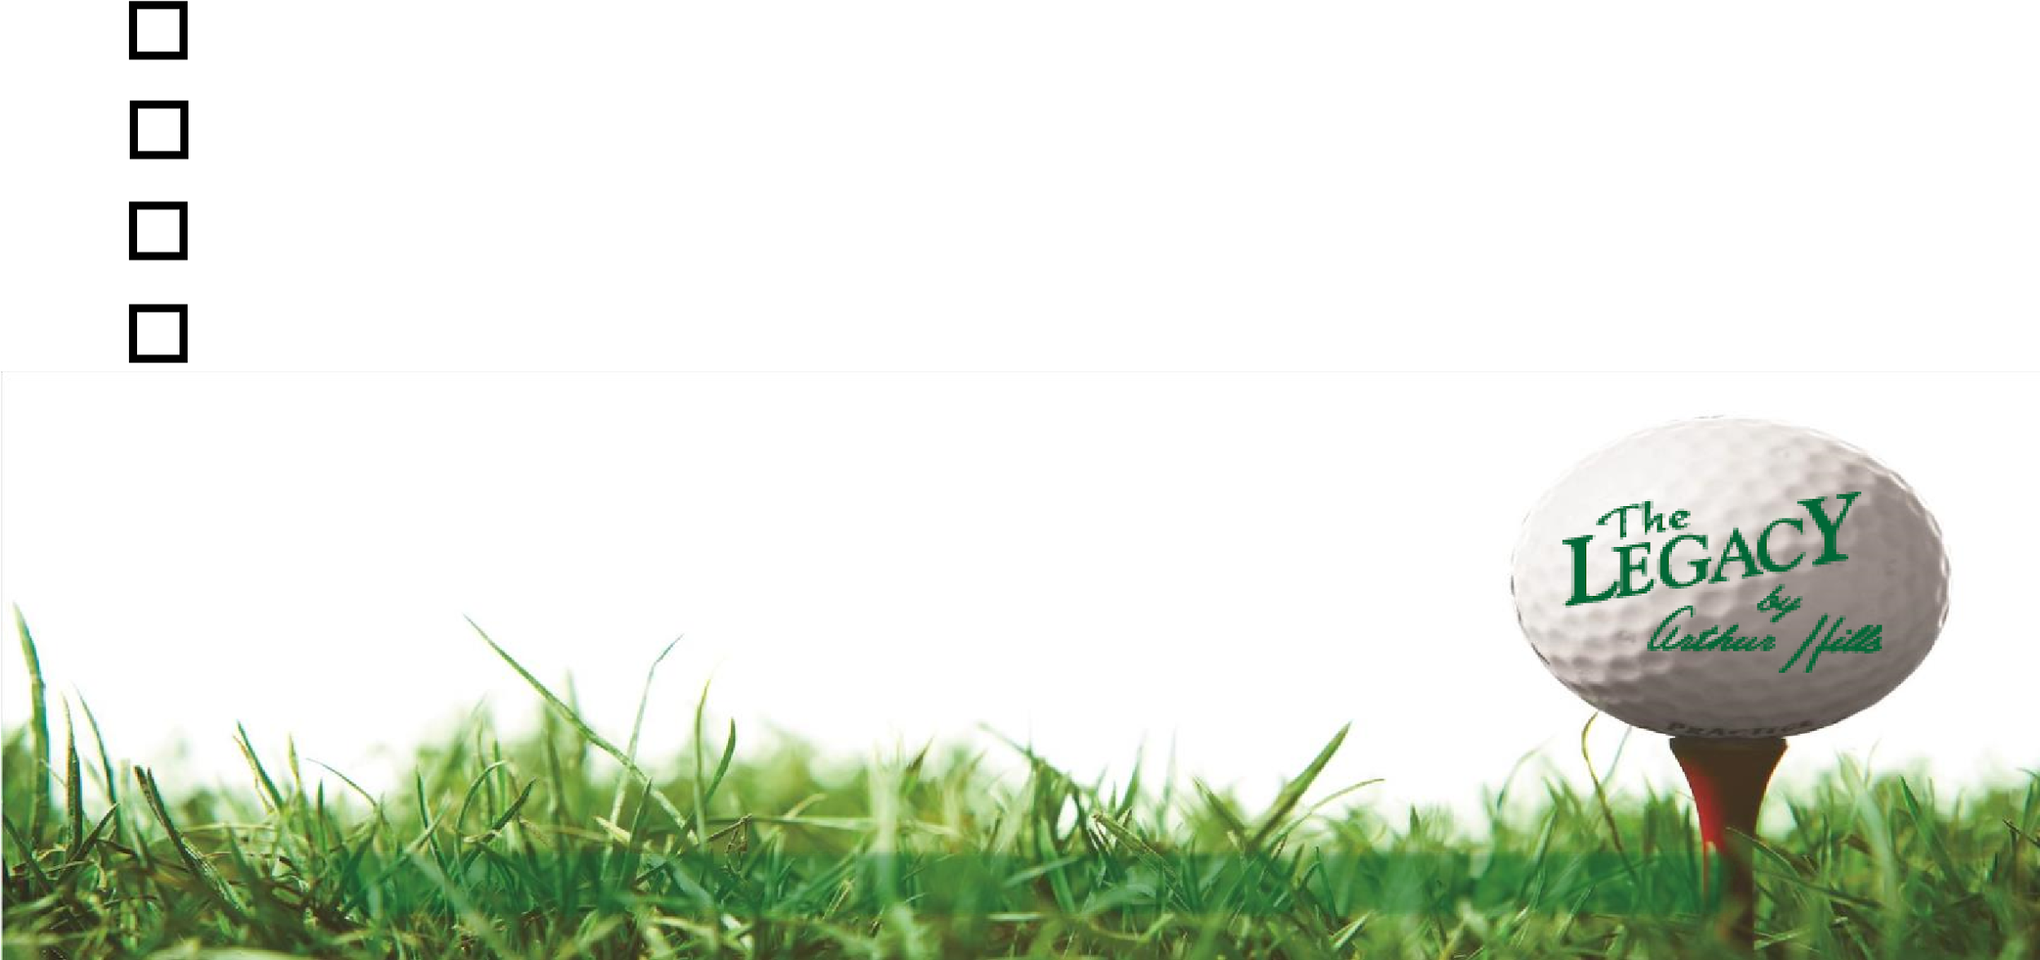
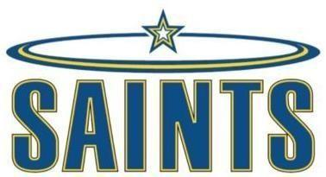
HOLE SPONSOR
SIENA HEIGHTS BASEBALL GOLF OUTING – Circle One
- $200 BRONZE HOLE SPONSORSHIP– SHU Baseball Hat
- $350 SILVER HOLE SPONSORSHIP– SHU Bucket Hat & BP Jacket
- $500 GOLD HOLE SPONSORSHIP– SHU Golf Polo & Baseball Hat
- $250 BEVERAGE CART SPONSORSHIP– SHU Baseball Sweatshirt
Make Checks Payable to: Siena Heights Baseball

Event Contact:
John Kolasinski
Cell: (517)-902-5193 Work: (517) 264-7872
Email: jkolasin@sienaheights.edu

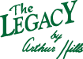
Outing is Friday, August 9, 2024
Please return this portion to John Kolasinski by email or mail to:
SHU Baseball 1247 E. Siena Heights Drive Adrian, MI 49221
Deadline to return is July 15, 2024

Company Name: __________________________________________________
Contact: ________________________________________________________
Phone: __________________________________________________________
Address: _________________________________________________________
Email: ___________________________________________________________
Notes: ___________________________________________________________

